

***Water Wise Landscape Design***

**Worksheet: Week 2, Exercise 7**

Name: _John Brand_______________________

**Design Principles**

1. Visiting a noteworthy public garden (such as Denver Botanic Gardens) and/or private gardens taking pictures that illustrate good examples of the design principles. [Note: Do NOT use photographs of your own garden!]
2. Insert the images into this document, adding captions explaining the photo and design concept. Size the picture to about half page width.

[22 points, one per picture]

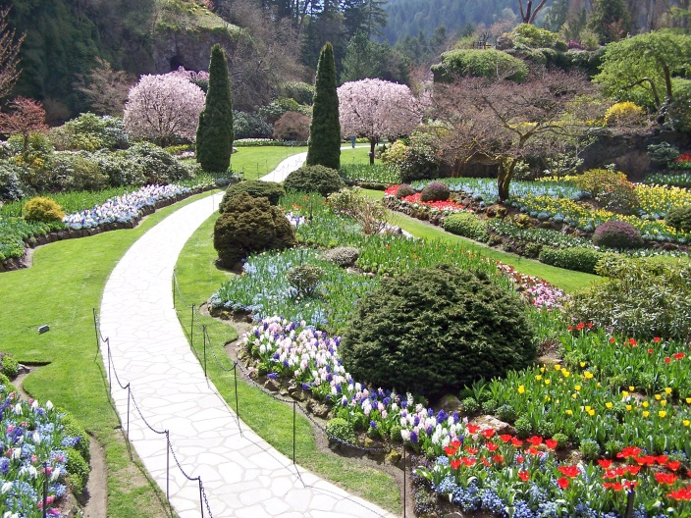For example:

* *Here at Butchart Gardens, the path (line) invites you to connect to the gardening exploring if beauty along the path.*

a. Three photos showing the strong use of *line* defining the space.

|  |  |
| --- | --- |
| The delineation between pedestrian sidewalk and raised bed gardens achieved by linear wooden fence. Denver Housing Authority Development, 10th & Osage, Denver, CO. |  |

|  |  |
| --- | --- |
| The progression from sidewalk-to-turf, turf-to-greens, and greens-to-broccoli in a community garden is emphasized by complementary linear designs. Denver Botanic Gardens community garden, Denver Housing Authority, 10th & Osage, Denver, CO. |  |

|  |  |
| --- | --- |
| Grass play area, bounded by curvilinear border, surrounded by rubber tarmac in children’s playground. Denver Housing Authority, 10th & Osage, Denver, CO. |  |

b. Two pictures showing eye catching use of various *forms*.

|  |  |
| --- | --- |
| Back patio area softened by, emphasizes the depth of private space. Denver Housing Authority, 10th & Osage, Denver, CO. |  |

|  |  |
| --- | --- |
| Another example of form, utilizing ornamental grass, to emphasize the depth of private space. Denver Housing Authority, 10th & Osage, Denver, CO. |  |

c. Two picture showing eye catching use of *texture*.

|  |  |
| --- | --- |
| Small-leafed vinca major alongside broad leaf broccoli in border garden. White Garth, St. John’s Episcopal Cathedral, Denver, CO. |  |

|  |  |
| --- | --- |
| Texture and color combine to make this the perfect 4th-of-July planter! Elbert County Extension Office, Kiowa, CO. |  |

d. A picture show effective use of warm color and one of effective use of cool color.

|  |  |
| --- | --- |
| Awww … Nothing compares to a manicured green lawn interspersed with trees on a late summer afternoon. So peaceful. Effective use of the cool color green. City Park, Elizabeth, CO. |  |

|  |  |
| --- | --- |
| This picture was taken around 6:30 pm. Notice how the white rock boarder accents the red and yellow colors, forcing the eyes up-to-the-sign! Strong use of warm colors red and yellow. Pinehurst Country Club, Denver, CO. |  |

e. Three pictures show effective sequence of colors (color sequence or color contrasts).

|  |  |
| --- | --- |
|  |  |

Left-to-right view of O’Fallon Perennial Walk, Denver Botanic Gardens, Denver, CO. Note how the colors on both sides of the walkway mimic each other!

|  |  |
| --- | --- |
| Impressive use of rock and water to highlight the green color scheme seen in bonsai trees, Japanese Garden, Denver Botanic Gardens, Denver, CO. |  |

|  |  |
| --- | --- |
| I wish I would have taken note of this bodacious purple broadleaf and the accompanying purple ornamental grass. These two elements really stand out when interspersed among boxwood border plants. Denver Botanic Gardens, Denver, CO. |  |

f. Two pictures show interesting use of *scale* (size and/or energy).

|  |  |
| --- | --- |
| Red border with upsloping yellow and blue repeat elements capped with green create the energy to fill the space. Traffic control island, Pinehurst Country Club, Denver, CO. |  |

|  |  |
| --- | --- |
| Nothing beats a Chihuly to fill a space! Chihuly glass sculpture added to The Ellipse, Denver Botanic Gardens, Denver, CO. |  |

g. Three pictures showing use of simplicity and variety. Identify what was the repeat element and what was the variety element.

|  |  |
| --- | --- |
|  |  |

Interesting use of repeat and variety elements along El Pomar Waterway, Denver Botanic Gardens, Denver, CO. Ornamental grass is the repeat element on the left side of the waterway, punctuated by container cactus and fountains. Clay pots accentuate different varieties of ornamental grass on the right.

|  |  |
| --- | --- |
| This is something that I did not expect at all!  Landscape design incorporating vegetables!  Boxwood is the repeating border element, highlighted by differing varieties of kale!  Le Potager Garden, Denver Botanic Garden, Denver, CO. |  |

|  |  |
| --- | --- |
| Another example of repeat/variety elements using vegetables. As before, the repeat element is Boxwood; the variety elements are Dutch Red Shauots and broccoli. Le Potager Garden, Denver Botanic Garden, Denver, CO. |  |

h. Two pictures show effective use of emphasis (dominance and subordination) of elements.

|  |  |
| --- | --- |
| Simple way to create dominance and subordination. The rock inlays dominate the surrounding turf area. Denver Housing Authority, 10th and Osage, Denver, CO. |  |
|  |  |
| When I first saw this, I thought that the water was the dominant element. No. The profusion of water lilies and other aquatic flora are the dominant elements. The water itself is the subordinate element! Monet pool, Denver Botanic Gardens. Denver, CO. |  |

i. Three pictures showing amazing plant combinations.

|  |  |
| --- | --- |
| This is of interest as the plant materials spilling out onto the walkway are dwarf watermelons. They form the repeat element, punctuated by tall flowering ornamental grass. I like the way vegetables are used in the design element! South African Plaza, Denver Botanic Gardens, Denver, CO. |  |

|  |  |
| --- | --- |
| This is an effective use of ornamental grass, sage, and echinacea to form border around a street light. I imagine the designers felt this was a more effective option than low-use turf. Denver Housing Authority, 10th & Osage, Denver, CO. |  |

|  |  |
| --- | --- |
| I think this is an artichoke, another example of vegetables used as landscape elements. Le Potager Garden, Denver Botanic Garden, Denver, CO. |  |